UNIVERSITY OF MELBOURNCE

COMP90019 RESEARCH PROJECT

25 CREDITS

The Feasibility of De-identificating

Based on External Dictionary

*Author: Supervisor:*

Ao Li Karin Verspoor

*A thesis submitted in fulfilment of the requirements*

*for the degree of Master of Information Technology*

Student ID: 798657

Department of Computing and Information System

May 30, 2018

**Abstract**

**Key words:** De-identification; External Dictionary;

Declaration

I certify that

- this thesis does not incorporate without acknowledgement any material previously submitted for a degree or diploma in any university; and that to the best of my knowledge and belief it does not contain any material previously published or written by another person where due reference is not made in the text.

- where necessary I have received clearance for this research from the University’s Ethics Committee and have submitted all required data to the Department.

- the thesis is _____ words in length (excluding text in images, table, bibliographies and appendices).

Acknowledgements

Thanks to my kindly supervisor Professor Karin Verspoor for her professional assistance, insightful guidance and patient support through my project. She offers the great help to me when I meet some challenges.

Thanks to my dear parents for their fully understand which keeps me positive.

Thanks to my lovely friends for their encouragement which makes me strong.

Contents

List of Figures v

List of Tables vi

1 Introduction vii

2 Project Description viii

3 Performance Analysis ix

4 Conclusion x

# List of Figures

**No table of figures entries found.**

# List of Tables

# 1 Introduction

In this chapter, the background about the necessity and current exist problem with clinical narratives and de-identification approach will be illustrated in turn firstly. Then, the improvement direction of de-identification approach in this project will be briefly described.

1.1 Background

1.1.1 Necessity of Clinical Narrative

A clinical narrative, as its literal meaning, is a first person “story” written by a clinician that each of it can describe a specific clinical event or situation for a particular patient. Obviously, Clinical narrative plays an important role in clinical decision making [1]. The value of writing the narrative clinicians are that it allows clinicians to not only explain and shared them diagnose with their patients, but also current clinical practice with their professional colleagues. In addition, the narrative can encourage clinicians more deeply analyse and reflect on their clinical practice so that give them more insight for diagnosing [2].

1.1.2 Problem with Clinical Narratives

However, these clinical texts contain a large amount of patient privacy information, such as name, address, phone number etc., which let patients’ personal confidentiality on the line. Also, with the development of Electronic Health Records (EHR) system, a large number of patients’ data nowadays can be readily accessed and provided through clinical text for several various background people [3]. Furthermore, the Health Insurance Portability and Accountability Act *(HIPAA)* explains that people or authorities need to get patients’ consent and the approval of the Internal Review Broad *(IRB)* before making use of their clinical texts, but lacking controls of all aspects make these requirements implacably in practice.

1.1.3. Necessity of De-identification Approach

Thus, for the sake of solving the problem of leaking out patients’ confidential information from the clinical narratives, de-identification approaches appear. In general, de-identification approach is such a kind of method to identify and remove patients’ privacy data, called as *Protected Hospital Identifier (PHI)* defined by *HIPAA* [3]*,* from the clinical texts so as to protect their personal details. An example of de-identification effect from *MIST Scrubber Toolkit* is shown as *Figure.1*. [5].



original clinical text

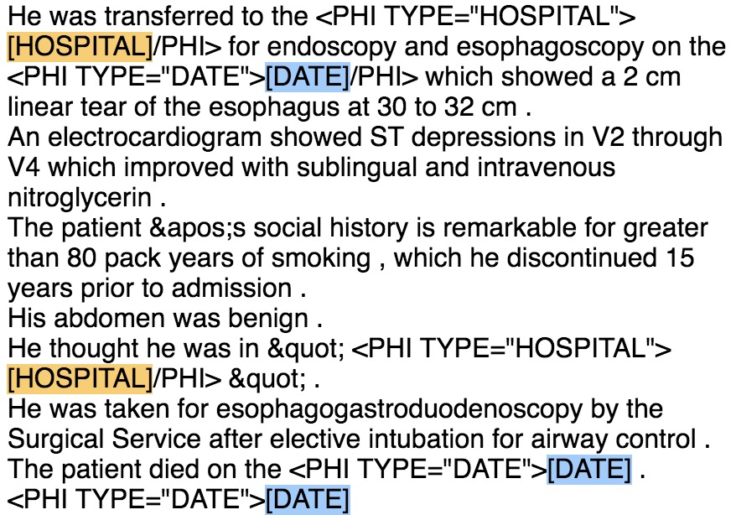

scrubbed clinical text

*Figure.1. Effect of De-identification*

1.1.4 Problem with De-identification Approach

Although from *Figure.1*., the effect of the de-identification process seems perfect, there are still many problems with current general de-identification approach, such as under de-identification (*Figure.2.(i)*), wrong de-identification (*Figure.2.(ii)*) and over de-identification (*Figure.2.(iii)*) … etc.

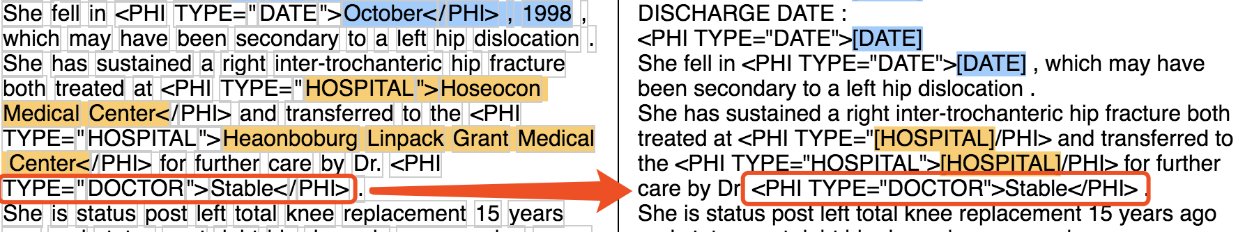

*(i) Under De-identification Example*

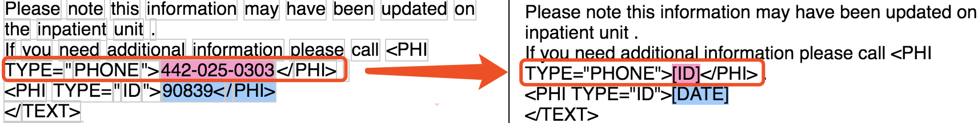

*(ii) Wrong De-identification Example*

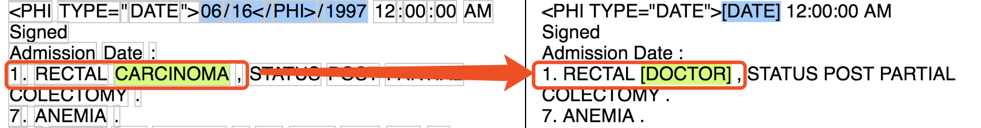

*(iii) Over De-identification Example*

*Figure.2. Some Problems with Current Scrubbed Tool*

1.2 Project Target

This project put forward a suppose that is whether use an external dictionary that is trained from the training data can help the de-identification process. And it narrows down the range of the category of the dictionary and will only focus on analysing ‘*Position*’ and ‘*Name*’ two categories instead. Furthermore, a novel approach, which will be called as *Colander Approach* in this project, will be implemented as a variant of de-identification method. It is such a process that only keep the terms that are wanted in the clinical narratives, meaning that it considers all other terms as *PHIs* and then try to get rid of them. More specific explanation of these two methods will be depicted in Section 2.

*Recall* and *Precision* will be considered as measurement for performance analysis in this project. The definition and calculation will be shown in Section 3.

Conclusion and future development will be put in Section 4, which will summarise the overall work in this project and give an overview of an direction of future development on de-identification approach.

# 2 Project Description (3000 words)

In this section, a comprehensive description of project environment settings and two types of de-identification approach will be introduced. Besides, four scrubber tools used in this project for de-identification will be detailed illustrated.

2.1 Project Environment Settings

2.1.1 Data Corpora

Different *EHR* systems provided distinctive framework of clinical narrative and they are generally unstructured [2], so it is crucial to select one specific data corpora for the experiment. In this project, dataset from the *Informatics Biology and the Bedside (i2b2)* organization will be used through the experiment. The reason for choosing i2b2 data is that:

1. It is such a popular dataset in biomedical computing and has an increased used for gaining insights to improve healthcare [6].
2. I2b2 dataset has provided sets of clinical notes from the *Research Patient Data Repository* at Partners HealthCare. Those notes have already tagged on multiple classes of PHIs and they are gradually improved these days, which supports later evaluation [7].
3. Multiple medical de-identification tools support to process on it. For example, the MIST scrubber toolkit the project will be used later has special command for processing i2b2 data rather than other datasets [5].

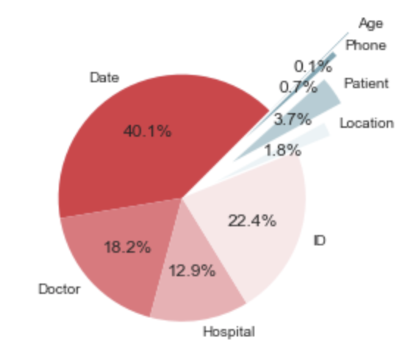

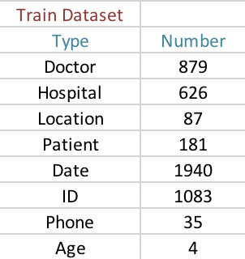

*Figure.3 Original Training Dataset*

More verbose, i2b2 annotated data corpora used in this project contains 201 records, which consists 4835 PHI instances from 8 PHI categories as shown in *Figure.3.* In this project, only ‘Doctor’, ‘Hospital’, ‘Location’ and ‘Patient’ category will be used, because they are more meaningful than others for the approach in this paper.

Because of small size and uneven distribution of the dataset, ‘*Doctor’* and ‘*Patient’ categories will be considered as ‘People’ category and ‘Location’ and ‘Hospital’ will be considered as ‘Position’ category in this project for easier analysis purpose.*

2.1.2 Evaluation Methodology

For the sake of analysing the performance of distinct de-identification approaches, *Precision* and *Recall* are considered as the evaluation methodology and both of them are desirable to be high in the experiment. The definition of them in this project are as following.

2.1.2.1 Precision

The definition of *Precision* is the fraction of relevant instances among all of the retrieved instance. Namely, the precision for a category is the number of true positives over the total number of terms labelled as belonging to the positive class. As for this project, to one specific classes of PHI, *Precision* is the number of correct scrubbed terms divided by all scrubbed terms (as shown in *Figure.4.*), meaning the proportion of right de-identification terms within all of the scrubbed terms.

$$Precision= \frac{\# Correct Scrubbed Terms}{\# Scrubbed Terms}$$

*Figure.4. The definition of Precision*

2.1.2.2 Recall

Generally, the definition of *Recall* is the fraction of relevant instances that have been found over the total amount of relevant instances. In other words, it is the number of true positive over the total number of terms that actually belong to the positive class. Take the project experiment data into the definition of *Recall*, it becomes, to one particular PHI category, the number of correct scrubbed terms divided by the total number of all tagged terms in the original text, which means the proportion of correct de-identified PHI terms in all of the PHI terms. Thus, the definition of *Recall* for each PHI class can be regarded as *Figure.5*.

$$Recall= \frac{\# Correct Scrubbed Terms }{\# Tagged Terms }$$

*Figure.5. The definition of Recall*

2.2 De-identification Approach Description

There are two main types of method implemented in this project. The first one is to modify the general de-identification approach by using external dictionaries of some of the PHI category that are trained from the project data corpora. Then, in the second part, called *Colander* approach, is an opposite way of de-identification that it will only contain the terms that are wanted. The following two sub-section will describe these means in detail.

2.2.1 Modified De-identification Approach

In this part, a concept of training dictionary will be introduced as a way to modify the general de-identification approach. The steps of the modified de-identification method are as below:

1. Split original dataset into training part and test part:

Randomly select 90%, 80%, 70%, 60% and 50% from the original dataset as the training set respectively (*Figure.6.)* and the rest of the original dataset will be taken as the test dataset.

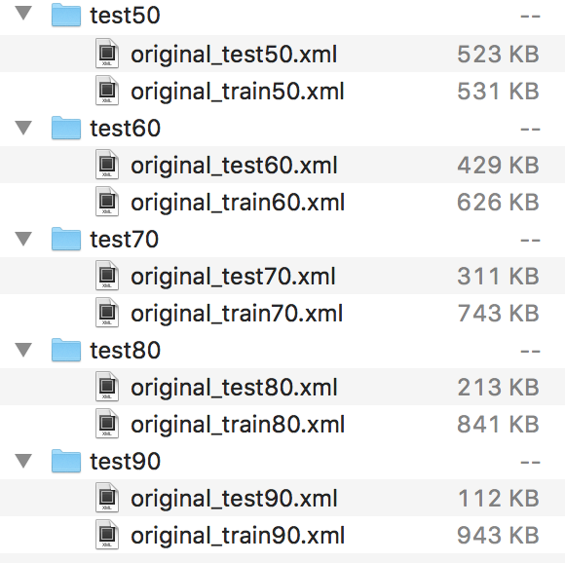

*Figure.6. Split original dataset*

1. Use the training part to train the external category dictionary:

Some of the scrubber tools do not differentiate ‘Doctor’ and *‘Patient’* name or ‘*Location’* and *‘Hospital’* position, so combine *‘Doctor’* and *‘Patient’* as People and *‘Location’* and *‘Hospital’* as ’*Position*’ in this project when training the dictionary. It is such a simple way for training the dictionary, which just retrieves some categories’ tagged *PHI* terms. For example, need to find *‘Hospital’* and *‘Location’* PHI tags for building a *‘Position’* dictionary. An illustration of the training process is as *Figure.7.*

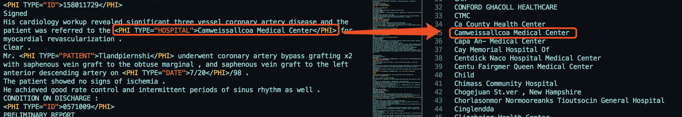

*Figure.7. Train the dictionary*

Then collect all of the retrieved terms together and sort them to be a new external dictionary and get the *‘Position’* dictionary file as *Figure.8*.

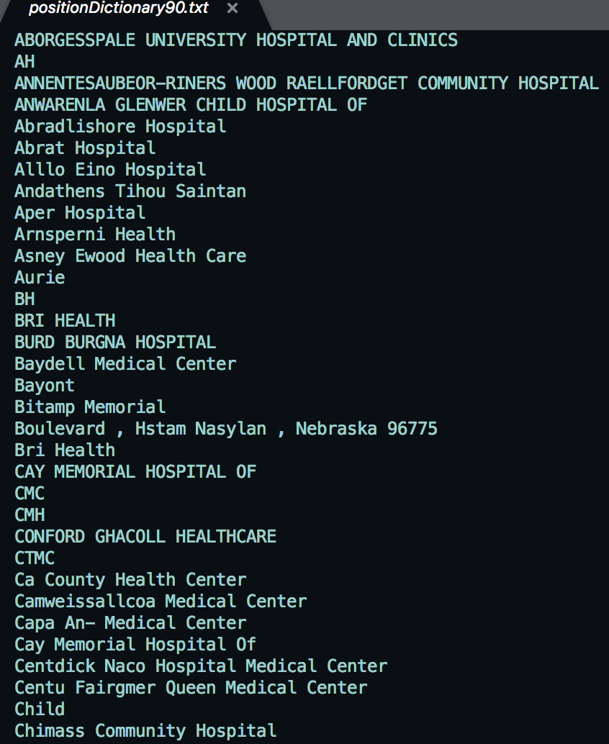

*Figure.8. An example of position dictionary*

1. Import the dictionary into the scrubber tools

Since there are two kinds of principle of the scrubber tools, it has two ways of using the external dictionary. To the pattern matching based scrubber tools, the dictionary file will be imported in and used directly as a matching file, which will be mapped to the test dataset later for scrubbing. However, to the machine learning based scrubber tools, the dictionary file cannot be applied straightforward, because the tools need to learn *PHI*’s features itself by using machine learning algorithm. Thus, the original training dataset will be provided to the machine learning tools instead of the learned dictionary.

1. Test the performance on the test part of the dataset:

Now can use the scrubber tools to process on the test dataset. More details about the scrubber tools will be introduced in Section 2.3. And Section 3 will give analysis and estimation about the modified de-identification approach and the comparison of de-identification effect among scrubber tools.

2.2.2 Colander Approach (500 words)

2.3 De-Identification Tools Description

There are four various scrubber tools that are used in this project for scrubbing the clinical narratives. And they can be divided into two types ----pattern matching based tools and machine learning based tools. In this project, *HMS Scrubber, De-ID Scrubber and PHI-Reducer* are based on pattern matching principle, but *MITRE Scrubber Toolkit* is on the strength of machine learning based method. The purpose for choosing these tools are that, 1) All of them are supported and processed on i2b2 data format. And 2) They are free, open source and easy to modify. More detailed introduction of these tools is as below sub-section.

2.3.1 HMS Scrubber

HMS Scrubber is an *HIPPA* compliant and de-identification tool tailored for pathology reports [3]. For the sake of removing tagged PHI*, HMS Scrubber* has three steps to do the de-identification [8], which are as the following:

1. Pre-process and convert the clinical text into a specific XML format, which includes a header and a body portion of the clinical report. An example of the header section of the XML format is shown in *Figure.9*.

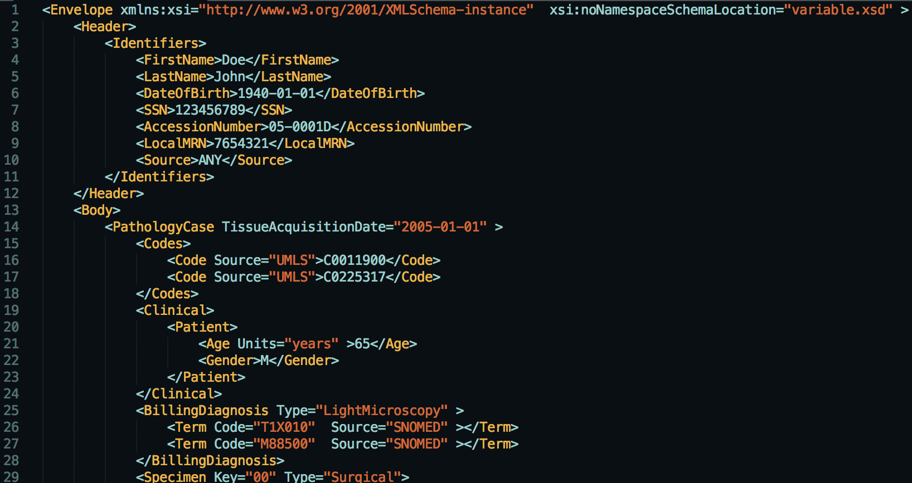

*Figure.9. The header of XML format in HMS Scrubber*

1. Use regular expressions (*RegExp*) and libraries for identificating potential PHI terms. There are about 50 *RegExp*s in the scrubber library. Additionally, popular suffixes and prefixes that are likely to stand for names (e.g. Dr., Mr. … etc.) are applied in this step for detecting. Take *‘Doctor’* PHI category as an example, *HMS Scrubber* has a very detailed *RegExp* description for detecting possible doctors pattern as in *Figure.10.*

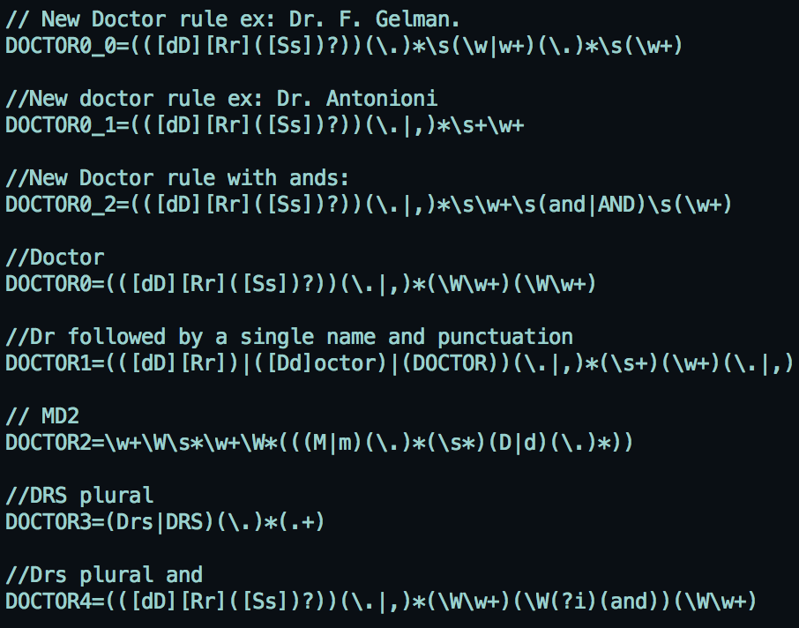

*Figure.10. RegExp for detecting Doctor*

Besides, there are two sorts of library in this method that are Person names and Hospital names for recognizing the patients’ name and the hospital they are in. Because these libraries are allowed to be augmented, the external dictionary generated from this project can be imported into the library in this step. The exist library is as depicted in *Figure.11.*

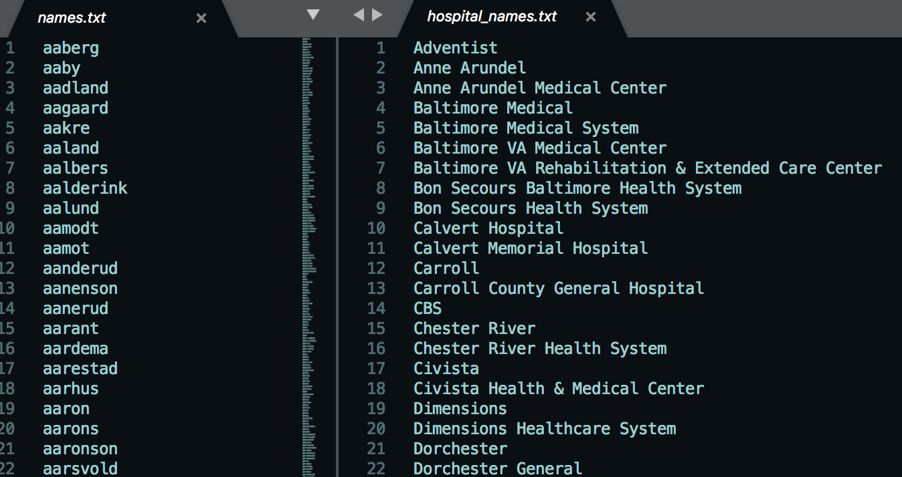

*Figure.11. Library for people and hospital names*

1. Replace all of the recognized words with a series of category tags.

The comparison of the original text and the scrubbed text output by *HMS Scrubber* is as *Figure.12.*



*Figure.12. The de-identification effect of HMS Scrubber*

2.3.2 De-ID Scrubber

*De-ID Scrubber* is a commercial tool created and developed at the *University of Pittsburgh* [9]. It also uses pattern matching algorithms with the help of dictionaries to recognize PHI terms. In addition, the de-identification steps in *De-ID Scrubber* is very similar to *HMS Scrubber*. However, major difference between *HMS Scrubber* and *De-ID Scrubber* is the number and the size of the dictionary that *De-ID Scrubber* has a more comprehensive dictionary library rather than *HMS Scrubber*. The basic process of *De-ID Scrubber* method is as following:

1. Pre-process and reformat the original clinical narrative into a fixed structure (*Figure.13*.). Obviously from the diagram, there are a start, a body and an end section for each clinical record. Thus, need to transform the original i2b2 format into this new structure firstly.

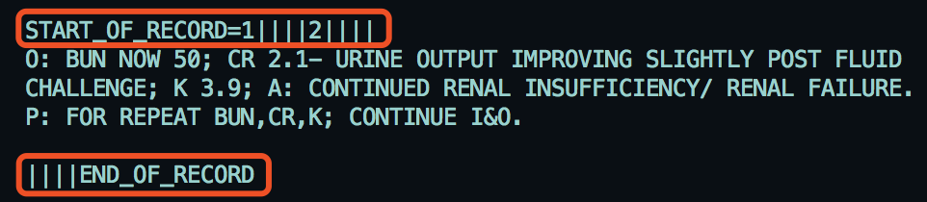

*Figure.13. The fixed structure in De-ID*

1. Use *RegExp* and dictionaries to detect PHI terms. As mentioned above, the number of the original dictionaries in *De-ID Scrubber* libraries are much more complete than *HMS Scrubber*. For instance, there are many classifications of dictionaries about person and location names and parts of the dictionary are shown in *Figure.14. (i).* Besides, it adopts the *UMLS Metathesaurus* to help in identifying medical words that should be kept with the text that are described in *Figure.14. (ii).* Obviously, the training dictionaries that are generated from the project training can import into this tools in this step.

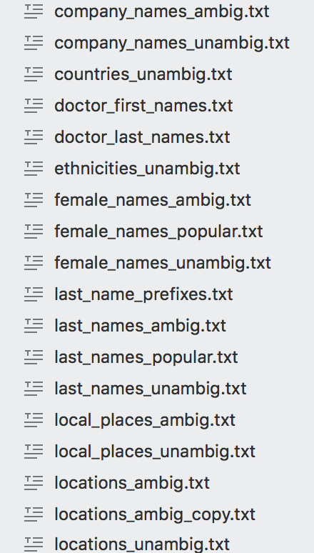 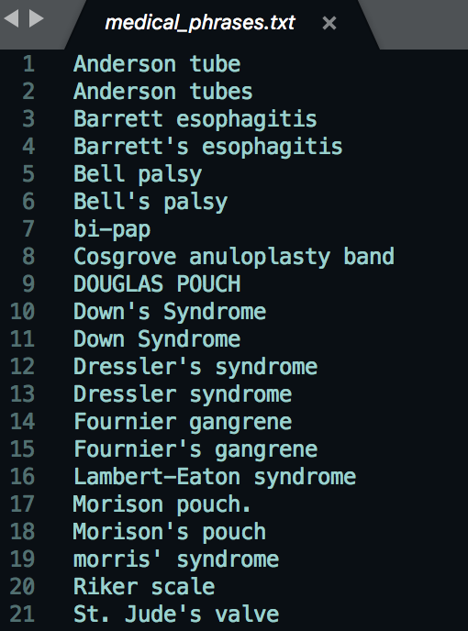

*(i) Comprehensive dictionary category (ii) Example of Metathesaurus*

*Figure.14. Example of dictionary in De-ID*

1. Replace all of the recognized words with a series of category tags.

The comparison of the original text and the scrubbed text output by *De-ID Scrubber* is as *Figure.15.*

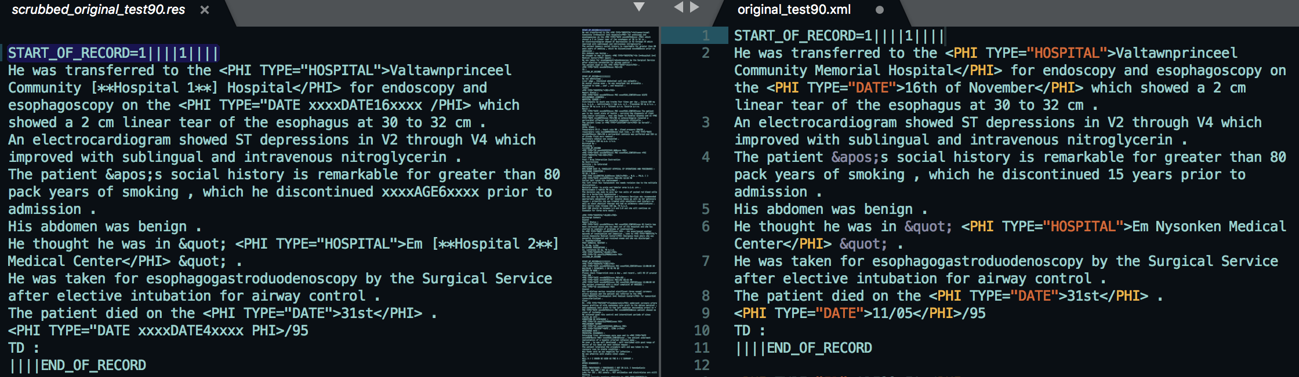

*Figure.15. The de-identification effect of De-ID Scrubber*

2.3.3 PHI-Reducer

*PHI-Reducer* is a pattern matching based de-identification tools. Compare it to the scrubbers that are mentioned above, the detection processes in PHI-Reducer are in multiple levels --- document level, sentence level and word level, which are more likely to identify the potential *PHI* terms to some extent. Moreover, *PHI-Reducer* is an application that makes use of the *Natural Language Toolkit (NLTK)* and the *SpaCy Packages,* which make it contain two ways for identifying names by using *NLTK* and *SpaCy* separately. Also, what need to be highlight is that *PHI Reducer* is such a toolkit that supports multi-processing, which means that it can be run in parallel and all the library, it is much more efficient than other tools when the dataset is large. However, there are not dictionary libraries used in this tool, but it has a large amount of *RegExp* for identifying the possible *PHI* terms. The basic scrubber procedures are as following:

1. Use *RegExp* to search for salutations. Most of the salutations are represented by a ‘.’ symbol, so this process must be done before the document is separated into sentences, meaning that it is in a document level. An example of the RegExp for checking salutations is depicted in *Figure.16*.

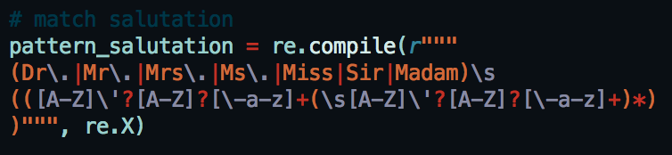

*Figure.16. An example of RegExp for salutations*

1. Split documents into sentences and use *RegExp* to identify PHI terms. In this level of *RegExp*, the pattern will consider only one word at a time. For example, it will identify the word ‘email’, ‘DOB’, ‘Postcode’ or any other word containing 5 or more digits. The external dictionary can be implemented in this part as a list of words to identify. And all of these matching is worked by the setting *RegExp*. *Figure.17.* gives an example of the ‘*Date’ RegExp* used in PHI-Reducer.

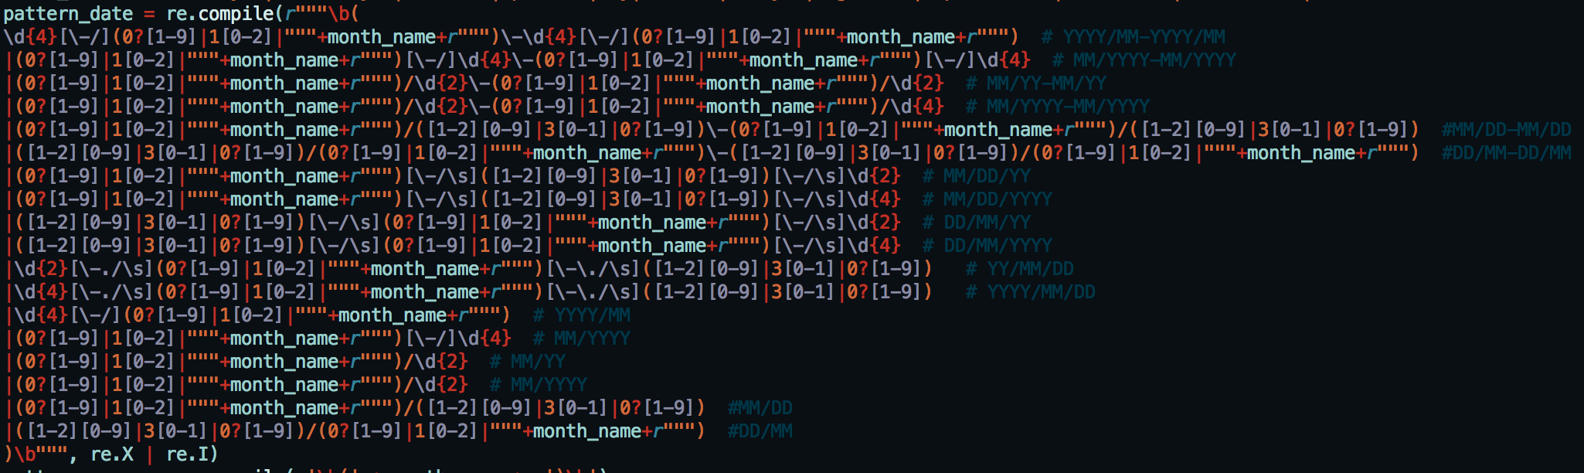

*Figure.17. Date RegExp in PHI-Reducer*

1. Split sentences into words and use *RegExp* to identify the context of PHI terms. For instance, checks the preceding words ‘age’ or ‘years’ for PHI terms ‘DOB’. Another example is about the address, PHI Reducer thinks that an address is supposed to contain the following indicator in *Figure.18.*

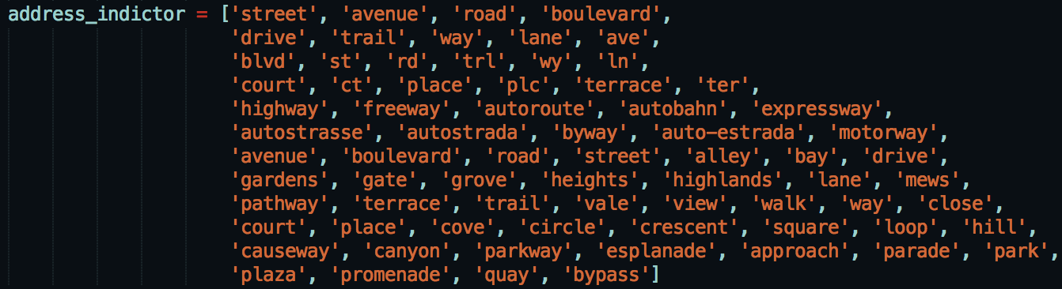

*Figure.18. Address indicator for PHI Reducer*

1. Use both *NLTK* and SpaCy toolkit to label a term and see whether they get the same label. If so, identify the word as a PHI terms. If not, add this term into a whitelist as a protected word.
2. Scrub all of the word that are recognized as a PHI words.

2.3.4 MITRE Identification Scrubber Toolkit (MIST)

*MIST* is the only machine learning based tool used in this project, which makes use of the *Conditional Random Fields (CRF)* classifier for automatically learning features of PHI terms from the training clinical narratives to de-identify medical texts and protect patients’ sensitive information [10].

There are two different de-identification tasks inside the *MIST* application that they are the *AMIA* task and the *HIPAA* task. In this project, only *AMIA* task is used and the main reason is that there is not much difference between these two tasks. Fundamentally, the distinction between these two methods is that *AMIA* task contains eight annotation classes, but *HIPAA* consists 18 categories, whose annotations are more detailed than *AMIA* task. However, since i2b2 used as dataset in this project and the categories of i2b2 dataset is the same as in the *AMIA* task, so *AMIA* task is completely enough in this experiment.

The general scrubbing process for *MIST* is as below:

1. Pre-process and reformat the training dataset. Because the original i2b2 data is not in the appropriate format on *AMIA* task. There are two main reasons, which are
2. The original i2b2 file is too large, but *MIST* can only process on small size of file. So, it is necessary to separate the large file into some small portions. And in *MIST*, it separates the large file by identifying the ‘ID’ in the context and split the file by ‘ID’ (*Figure.19.).*

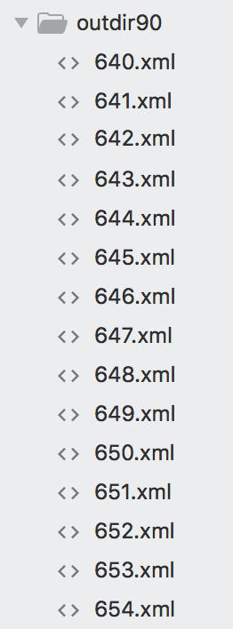

*Figure.19. An example of splitting the file*

1. The annotation style of i2b2 is *ENAMEX-style*, however, *AMIA* task need to run on *PII-style*. Therefore, need to reformat the annotations. The comparison between the original i2b2 data and data after reformatting is shown in *Figure.20*.

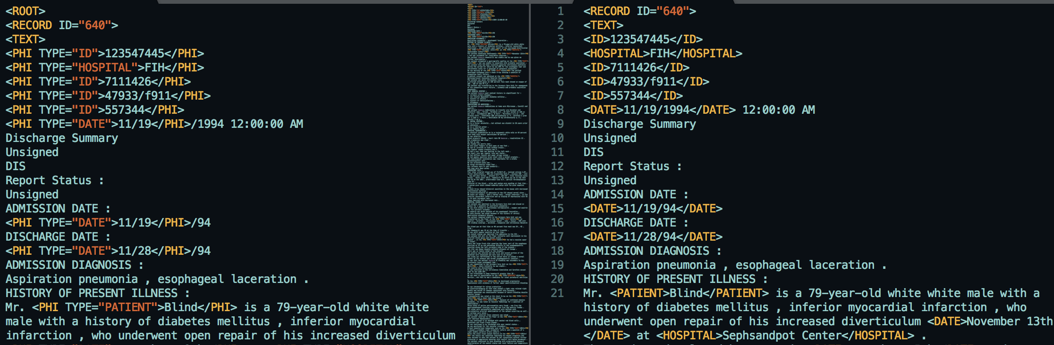

*Figure.20 The effect of the reformatting in MIST*

1. Use the reformatting dataset to build and train a model for de-identification. Because *MIST* is based machine learning algorithm, external dictionary cannot be imported into directly, need to use the reformatting dataset to train the model instead.
2. Scrub the narratives on the trained model. The key steps for processing de-identification are “zone, tag, nomination and transform”, which basically divide the original text into some small tokens, then tag each token and replace the *PHI* words with the specified replacer. A set of diagrams briefly shows the scrubbing process in *Figure.21*.

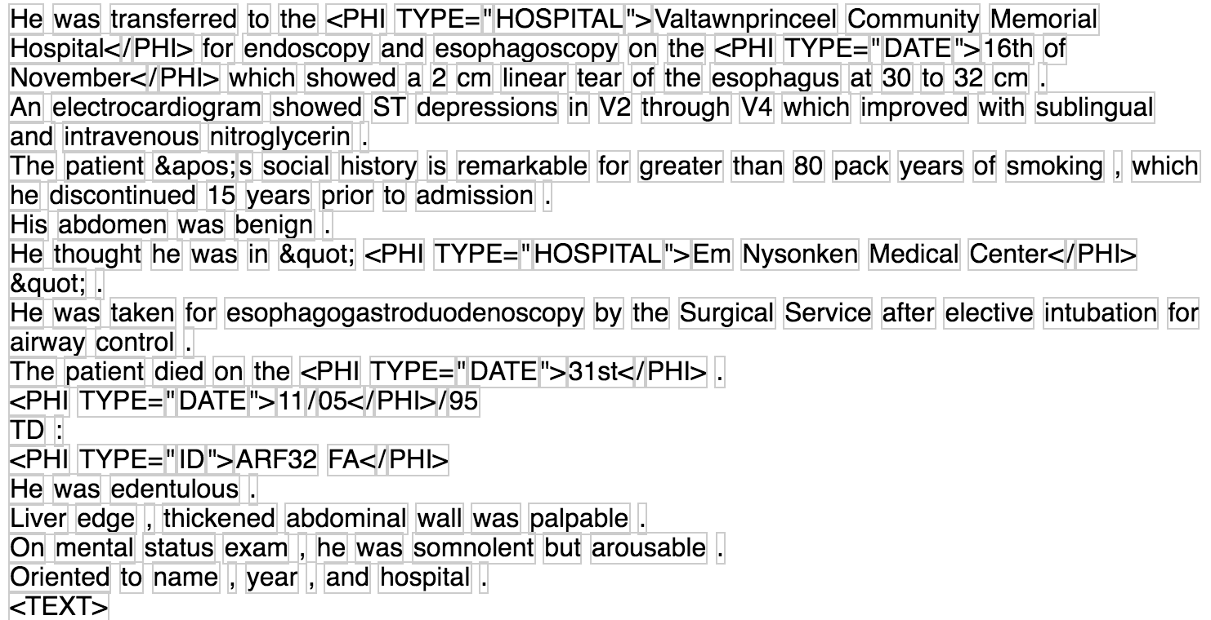 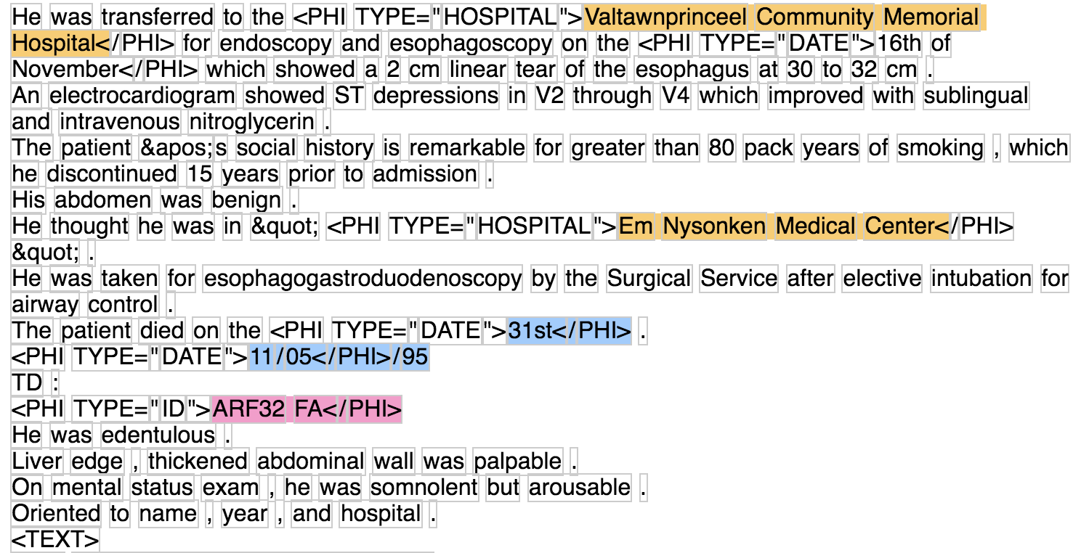

*(i) zone (ii) tag*

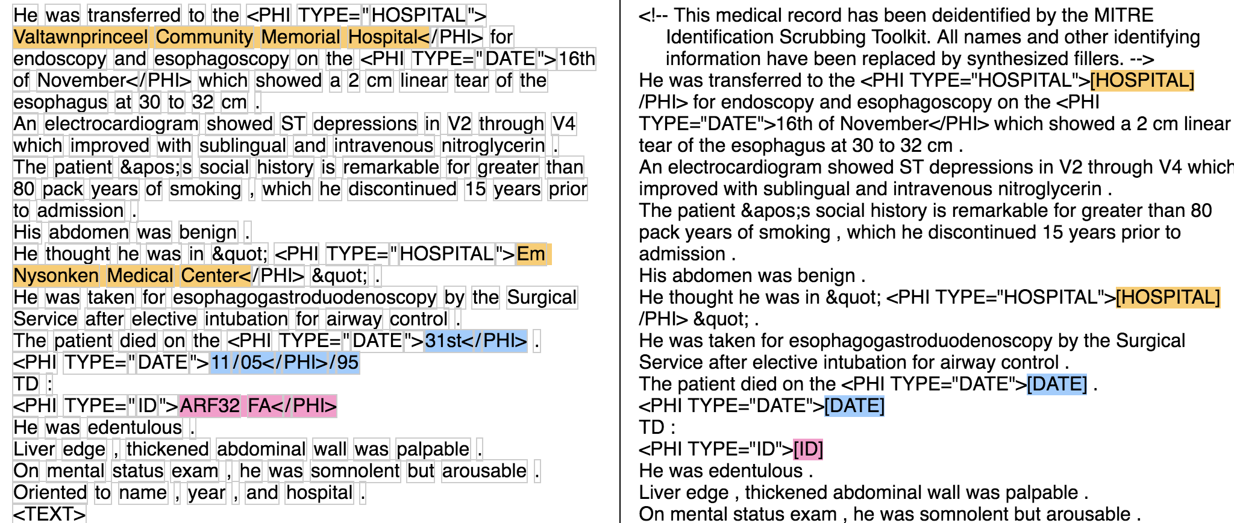

*(iii) nominate and transform*

*Figure.21. Basic steps for de-identification in MIST*

*Note:* ***zone:*** *find appropriate regions’ boundaries of the document to process.* ***tag:*** *add PII annotations.* ***nominate****: create replacement phrases for the regions of text tagged with PII annotation.* ***transform****: replace PII annotation with the replacer.*

# 3 Performance Analysis (4000 words)

In this section, some doubts and insights will be gained from observing the value of *Recall* and *Precision* in every experiment. Thus, a detailed performance analysis for the modified de-identification approach and colander approach will be presented.

3.1 Modified De-identification Approach Analysis

In order to assess the efficiency of the external dictionary, there are a series of analysis from multiple aspects that will be described as following steps:

* Firstly, the assessment will be generated from the comparison of performance in whether to import an external dictionary with different scrubber tools.
* Then, it will contrast the effect of different category dictionaries on various de-identification tools.
* Finally, a hold-out experiment and a ten-fold cross validation evaluation will be processed on the best performance scrubber tools that is analysed from the previous two steps.

3.1.1 External Dictionary Performance Analysis

An analysis of an external dictionary that are generated from the training file on four different scrubber tools is presented in this part. The external dictionary used in this section contains *‘Doctor’* name, *‘Patient’* name, *‘Hospital’* position and patients’ *‘Location’* together, which is such a kind of hybrid dictionary. The purpose of using this dictionary is to see the general de-identification performance of each scrubber, because different scrubber has distinct de-identification ability on various *PHI* category. Also, because the original i2b2 dataset has already separated into 5 types that takes 90%, 80%, 70%, 60% and 50% of the dataset as the training data respectively.

As mentioned above, there are two kinds of scrubber tools ---- pattern matching based and machine learning based. But the external dictionary cannot directly import into the machine learning based de-identification tools. Thus, this report will analysis pattern matching based tools and machine learning based tools in a different way.

3.1.1.1 Pattern Matching Based Scrubber Analysis

Since *HMS Scrubber, De-ID Scrubber and PHI Reducer* are all pattern matching based toolkit, they can be compared with each other. As shown in *Figure.22*., the first and second row describe the comparison of *Precision and Recall* respectively among different tools with various size of the training dataset and the left two diagrams means the *Precision and Recall* on the original scrubber and the right two charts represents the performance on the scrubber after external dictionary imported.

Obviously, to the original scrubber, *HMS Scrubber* gets the highest *Precision*, which is about 90%, but lowest Recall that is approximately 5.29%, and *PHI-Reducer* is in an opposite way that the lowest *Precision* is 42.93% and the highest *Recall* is 45.71%. And, both of the Precision and Recall in *De-ID Scrubber* performs in a middle level. More detailed about the data can see the *Appendix.1*.

Then, after importing the external dictionary, the Precision in both *HMS and De-ID Scrubber* has a dramatically decrease, however, both of the tools’ Recall grows vigorously that the Recall of HMS Scrubber has five-fold increase and De-ID Scrubber has increased by 3 times. Although there is also a slightly fluctuation in *PHI-Reducer,* but because it already has a relative high *Recall* and low *Precision*, so there is not much difference and it still provides the highest Recall after modified.

Additionally, there are 5 different external dictionaries that are generated from 5 different training datasets on disparate size, which is depicted as various colour in *Figure.22*. There is not much distinction among them from the diagram and, to some extent, it means the size of the training dataset has a small influence on the scrubber, but there are still some other reasons that cause this situation. Such as, the error of the random sampling, the diversity of the using dataset … etc. And, the charts still show the tendency that scrubbers get a relative high *Precision and Recall* with larger training dataset.

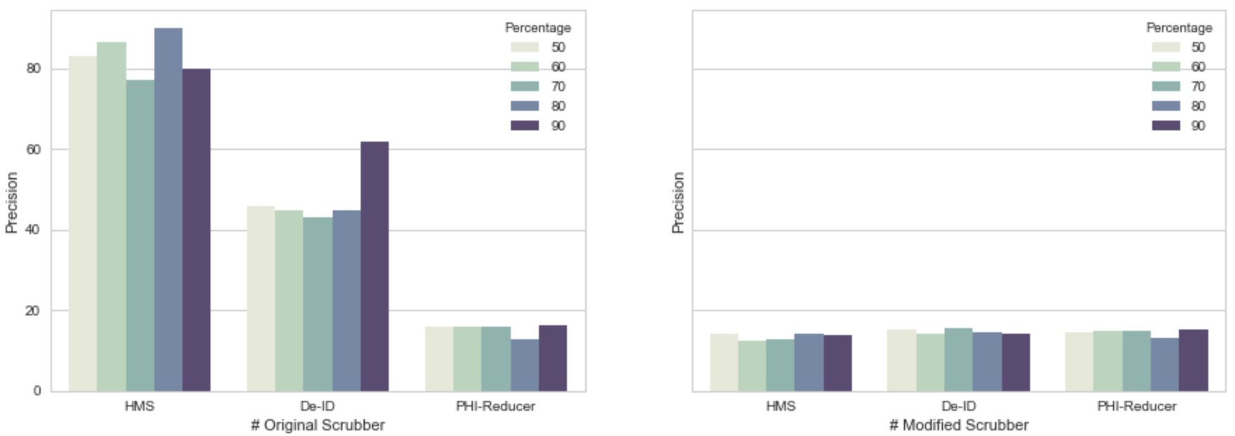

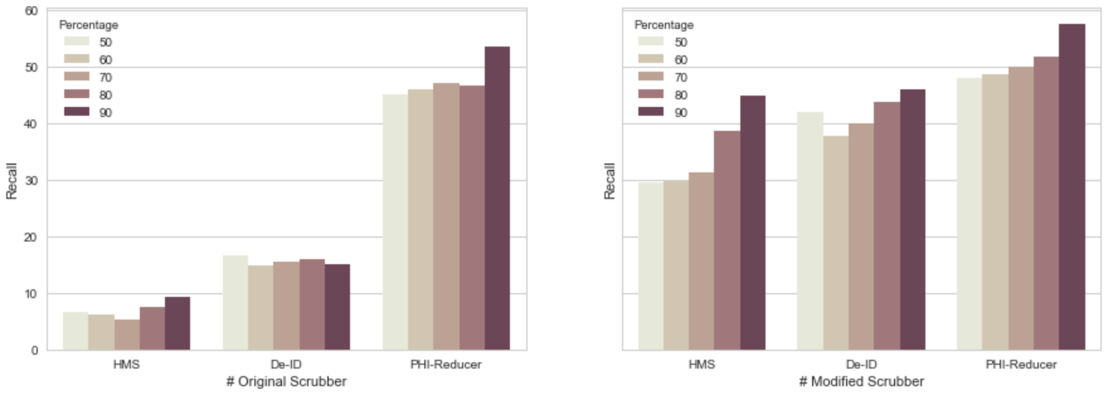

*Figure.22. The Comparison of Precision and Recall*

*on Pattern Matching Based Tools*

3.1.1.2 Machine Learning Based Scrubber Analysis

To the machine learning based scrubber, the analysis is in a different way. Because *MIST* is the only machine learning based tools used in this project, the performance analysis of *Precision and Recall* will be compared itself to different training iteration setting. It is well-known that the number of training iteration plays an important role in machine learning algorithm, which can sensitively control the training model so that avoids it becoming underfitting or overfitting. *Figure.23* is a cure graph which describes the trend of the *Precision and Recall* in different limitation of iteration based on *MIST*.

Firstly, as can be seen from the graph, the four curves show the fluctuation of the *Precision and Recall* value. The highest *Precision* in *MIST* is67.74%, which is nearly 2 times less than in pattern matching based tools. But the highest *Recall* is approximately 46.20% that is slightly higher than 45.71% in pattern matching based method. However, the highest *Precision and Recall* in *MIST* are both from the same iteration. This means that when the iteration is 10 in MIST, will gives a relative high *Precision and Recall*, which seems more stable than pattern matching based tools that there is a large difference between the *Precision and Recall*.

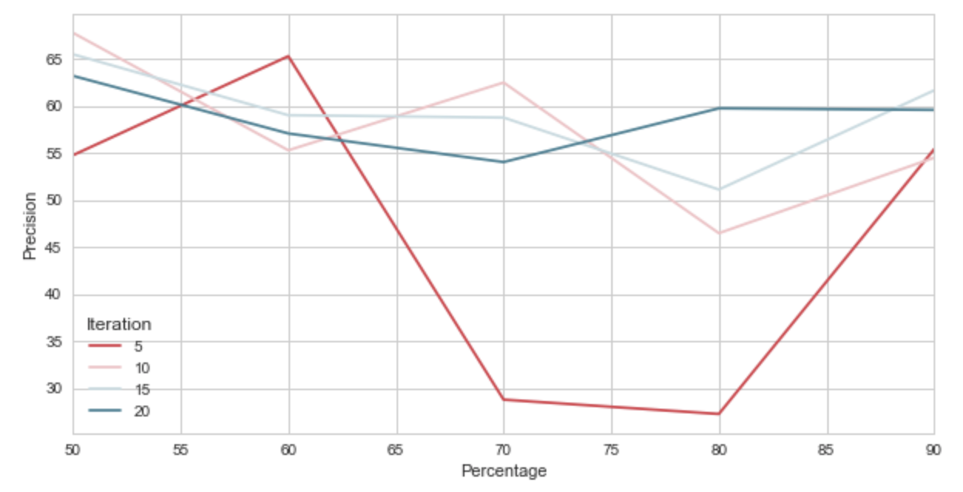

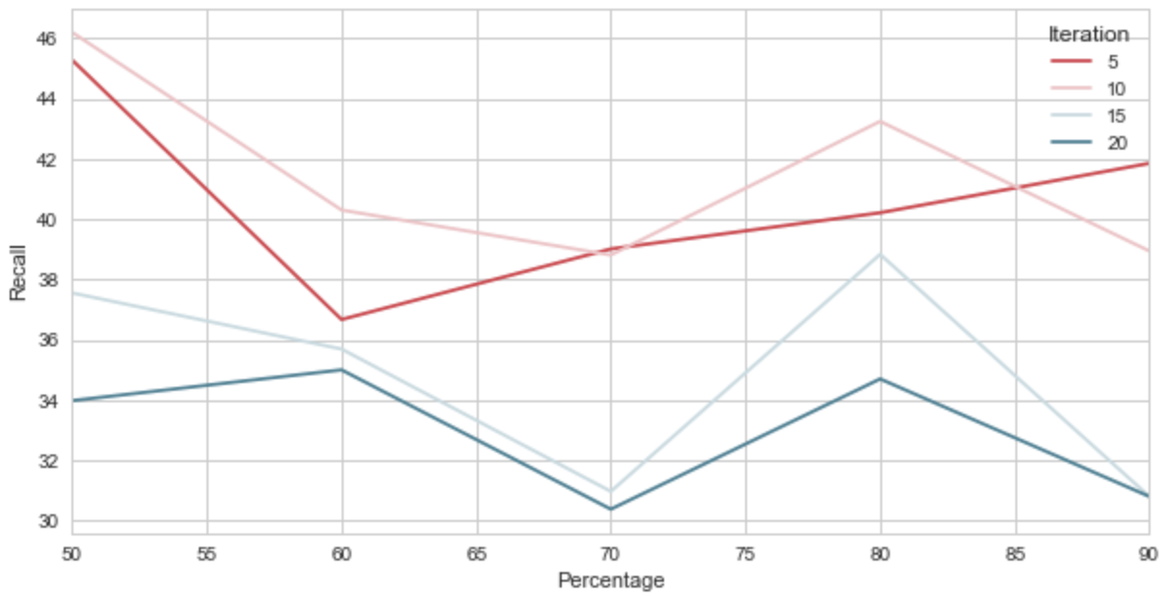

*Figure.23. The Comparison of Precision and Recall*

*on MIST with different setting*

Also, from the diagrams, it is clearly that when the iteration is 15 and 20, the training model for de-identification seems become overfitting, because it gives a relative high *Precision* but comparative low *Recall*. In contrast, it is apparent from the chart that when the iteration is 5, the training model looks underfitting, since the fluctuation of the red curves is much more dramatically than the others and the *Precision* is lower than the *Recall* in a large range of percentage.

In addition, as is demonstrated in the graph, the *Precision and Recall* are high enough when the training data is about 50%. It reveals one advantage of the machine learning based algorithm that PHI terms’ features can be well-learned only on a relatively small training dataset, though the dataset need to be tagged.

3.1.2 Different Dictionary Performance Comparison

In this part, a *‘Position’* and a *‘People’* external dictionary will be introduced respectively in the next two sub-sections. It is worth to noting that there is not distinction of people’s name and locations’ name in *PHI-Reducer* after scrubbing and machine learning based toolkit cannot directly import external dictionary, so the analysis in this part is only based on *HMS Scrubber and De-ID Scrubber*. In addition, as mention above, ‘Location’ and ‘Hospital’ and ‘Doctor’ and ‘Patient’ *PHI* categories are separately combined together as ‘*Position’* and ‘*People’* category.

3.1.2.1 Only Imported ‘Position’ Dictionary

According to *Figure.24*., the bar graphs show the *Precision and Recall* on the original *HMS Scrubber* and *De-ID Scrubber* and these scrubbers after importing the *‘Position’* dictionary. More specifically, the first row of charts represents the change of the *Precision* and the second row of charts stands for the *Recall*.

As can be seen from the graphs, before importing the ‘*Position’* dictionary, *HMS Scrubber* has a relative higher *Precision* but a lower *Recall.* However, after importing the dictionary, *De-ID Scrubber* performs better not only on the Precision side but on the Recall side. Moreover, although the *Precision* on *De-ID Scrubber* has decreased double, but the *Recall* has grown about three times, which is very desirable and achieves about 83.43% when the training dataset is only 50% of the original.

Additionally, to both two scrubbers, there is a considerable increase occurs on *Recall*, but an opposite tendency on *Precision*, which means that the external dictionary can really help the de-identification tools to find the *PHI* terms. In other words, it can improve the retrieval of the *PHI* terms.

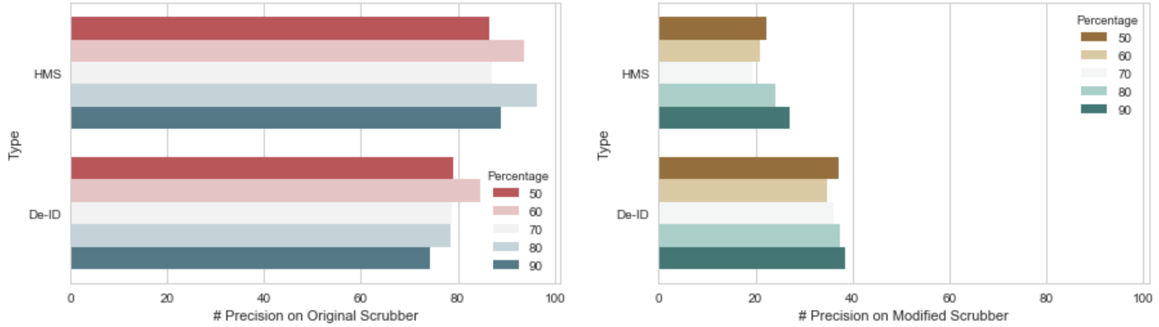

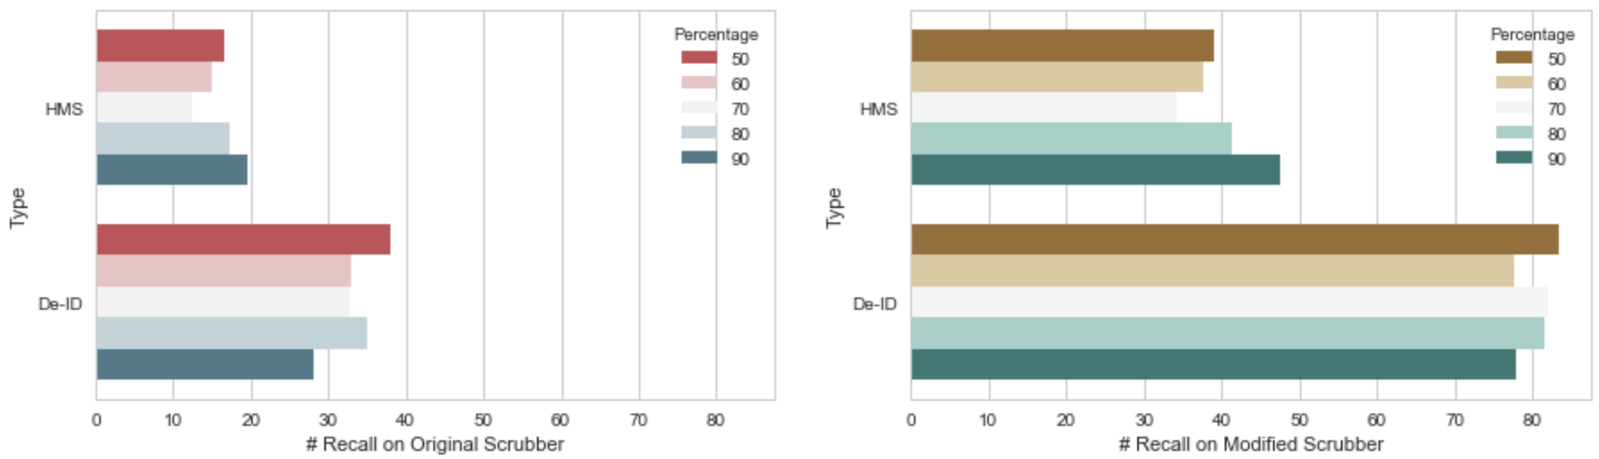

*Figure.24. The comparison of Precision and Recall on*

*original HMS and De-ID Scrubber with the scrubbers*

*after importing the ‘Position’ Dictionary*

3.1.2.2 Only Imported ‘People’ Dictionary

Although the way using for training the ‘*People’* external dictionary and the procedures processing on de-identification is similar comparing to ‘*Position’* dictionary, the performance of ‘*People’* dictionary shows in a completely different way as depicted in *Figure.25*.

Surprisingly, both *HMS Scrubber* and *De-ID Scrubber* do badly in scrubbing people’s name. As is shown in the diagrams, the original *HMS Scrubber* can hardly de-identify a *PHI* tagged name on the test dataset, which makes both of the *Precision and Recall* become 0. And although the original *De-ID Scrubber* performs a little bit better than *HMS Scrubber,* the average of *Precision* is still only about 6% except for the highest value in *Precision* and the situation is pretty similar in *Recall* as well that the average of Recall is approximately 3%.

The good news is that after modified the scrubbers, the value of *Precision and Recall* are both effectively increased. And the performance of *HMS Scrubber* is relatively satisfied than before, which receives at about 56% and 11% in the highest *Recall and Precision*.

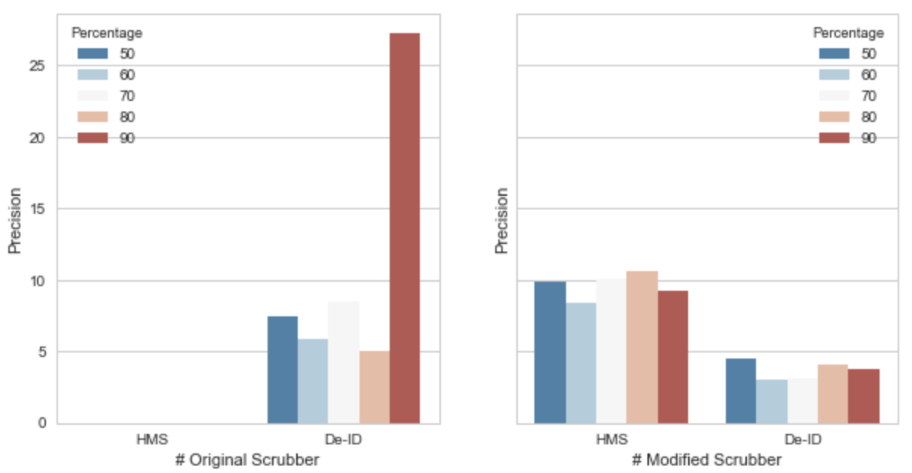

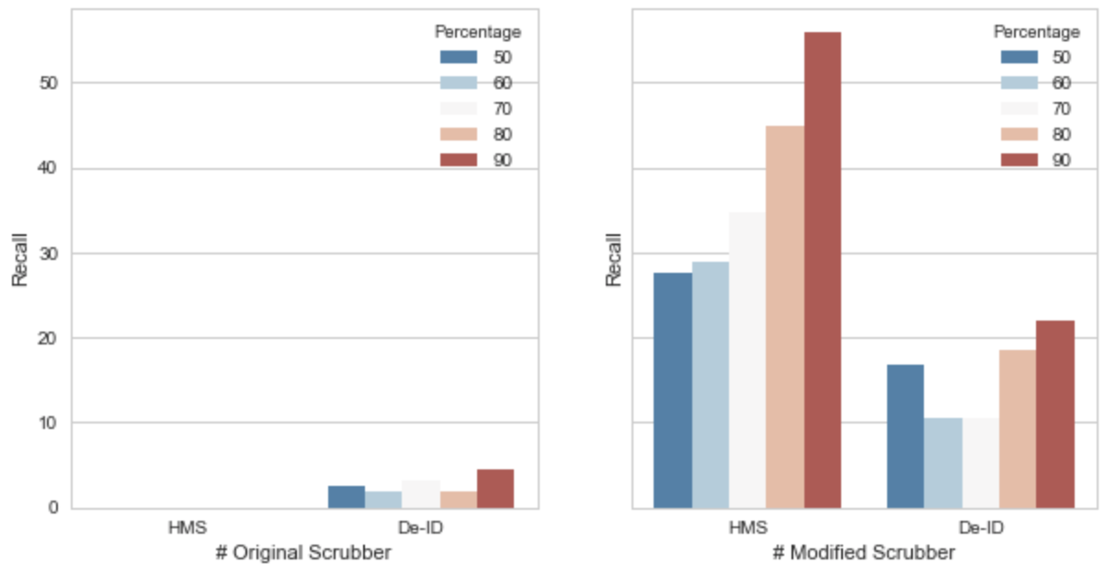

*Figure.25. The comparison of Precision and Recall on*

*original HMS and De-ID Scrubber with the scrubbers*

*after importing the ‘People’ Dictionary*

However, comparing to the *‘Position’* dictionary, ‘People’ dictionary still performs much worse. There are many reason for that the original scrubbers have difficulties in identifying people’s name and one of the major reason could be the diversity of people’s name. For example, people’s names are different a lot from different region and pattern matching based scrubbers generally use regular expression for identifying. It is very difficult to write a series of comprehensive regular expressions that can completely describe all kind of names.

3.1.3 Best Performance De-identification Tool Analysis

3.2 Colander Approach Analysis (1500 words)

# 4 Conclusion (500 words)

# Reference

[1] Murphy, J.W., Choi, J.M., & Cadeiras, M. (2016). The Role of Clinical Records in Narrative Medicine: A Discourse of Message. *The Permanente Journal,* 20(2), 103-108. doi:10.7812/TPP15-101.

[2] Ferrández, O., South, B., Shen, S., Friedlin, F., Samore, M., & Meystre, S. (2013). BoB, a best-of-breed automated text de-identification system for VHA clinical documents. *Journal Of The American Medical Informatics Association*, *20*(1), 77-83. doi:10.1136/amiajnl-2012-001020.

[3] Meystre, S. M., Friedlin, F. J., South, B. R., Shen, S., & Samore, M. H. (2010). Automatic de-identification of textual documents in the electronic health record: a review of recent research. *BMC Medical Research Methodology*, *10*70. doi:10.1186/1471-2288-10-70.

[4] Ferrandez, O., South, B. R., Shen, S., Samore, M. H., Meystre, S. M., & Friedlin, F. J. (n.d). Evaluating current automatic de-identification methods with Veteran's health administration clinical documents. *Bmc Medical Research Methodology*, *12.*

[5] Mist-deid.sourceforge.net (n.d.). MIST: The MITRE Identification Scrubber Toolkit. AMIA TASK [online] Available at: <http://mist-deid.sourceforge.net/current_docs/html/index.html> [Accessed 30 Mar, 2018]

[6] i2b2: The Intergrating Biology and the Bedside organization. (2005). [online] Available at: <https://www.i2b2.org/NLP/DataSets/Main.php> [Accessed 31 Mar,2018]

[7] Stubbs, A., & Uzuner, O. (2015). Annoatating longitudinal clnical narratives for de-identification: The 2014 i2b2/UTHealth corpus. *Journal Of Biomedical Informatics*, S20-S29. Doi:10.1016/j.jbi.2015.07.020.

[8] Beckwith, B.A., Mahaadevan, R. Bails, U.J., & Kuo, F. (2006). Development and evaluation of an open source software tool for deidentification of pathology reports, *BMC Medical Informatics & Decision Making*, 6(1), 12-10. Doi:10.1186/1472-6947-6-12.

[9] Gupta, D., Saul, M., & Gilbertson, J. (2004). Evaluation of a Deidentification (De-Id) Software Engine to Share Pathology Reports and Clinical Documents for Research. *AMERICAN JOURNAL OF CLINICAL PATHOLOGY*, (2). 176.

[10] Aberdeen, J., Bayer, S., Yeniterzi, R., Wellner, B., Clark, C., Hanauer, D., & … Hirschman, L. (2010). The MITRE Identification Scrubber Toolkit: Design, training, and assessment. *International Journal Of Medical Informatics*, 79, 849-859. doi:10.1016/j.ijmedinf.2010.09.007.

Appendix

Experiment Analysis Data

1. Analysis Data for section 3.1.1.1:

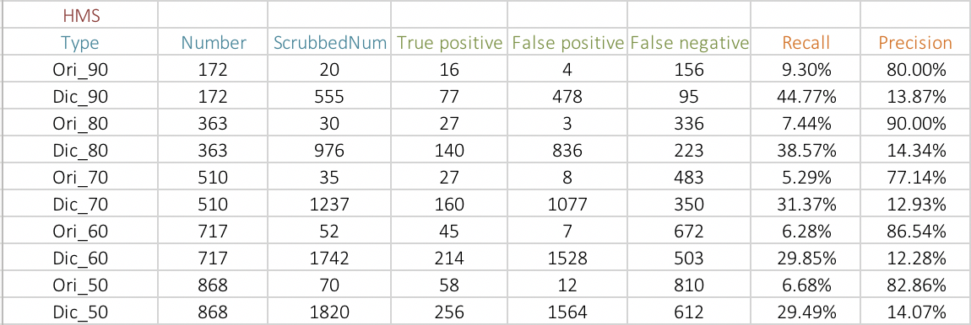

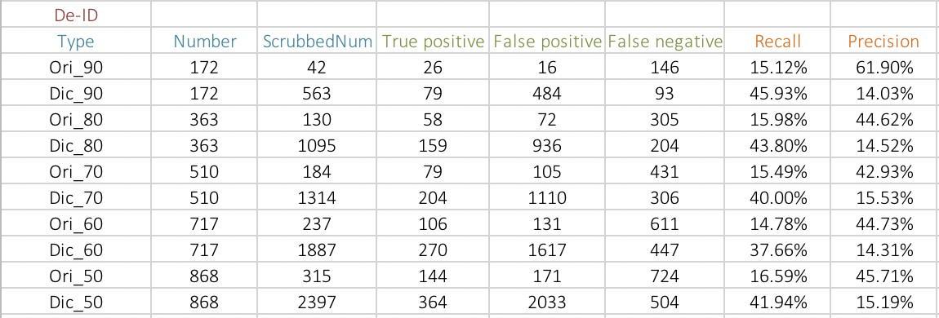

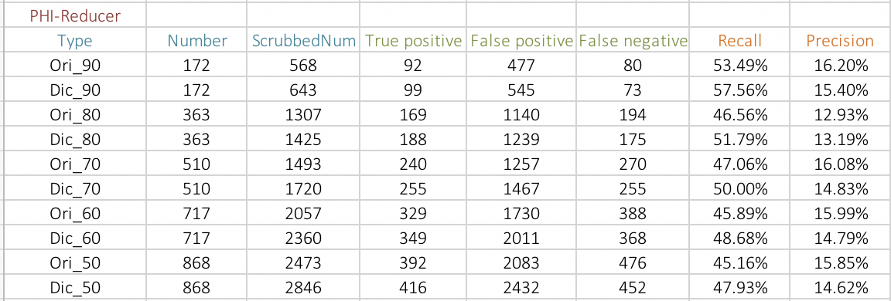

The Total Analysis among

The Pattern Matching Based Scrubber Tools

2. Analysis Data for section 3.1.1.2:

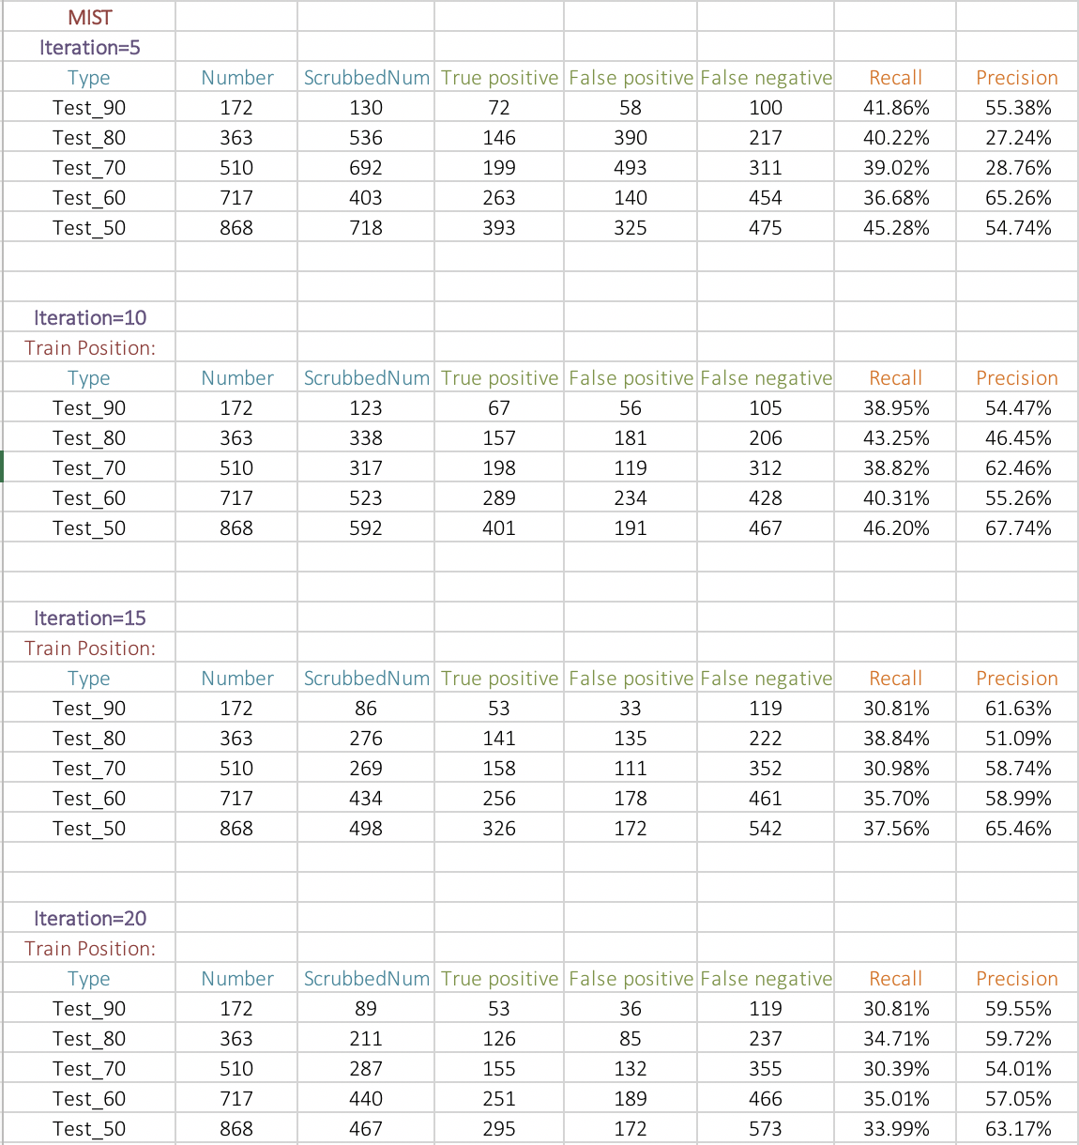

The Total Analysis among

The Machine Learning Based Scrubber Tools

3. Analysis Data for section 3.1.2.1:

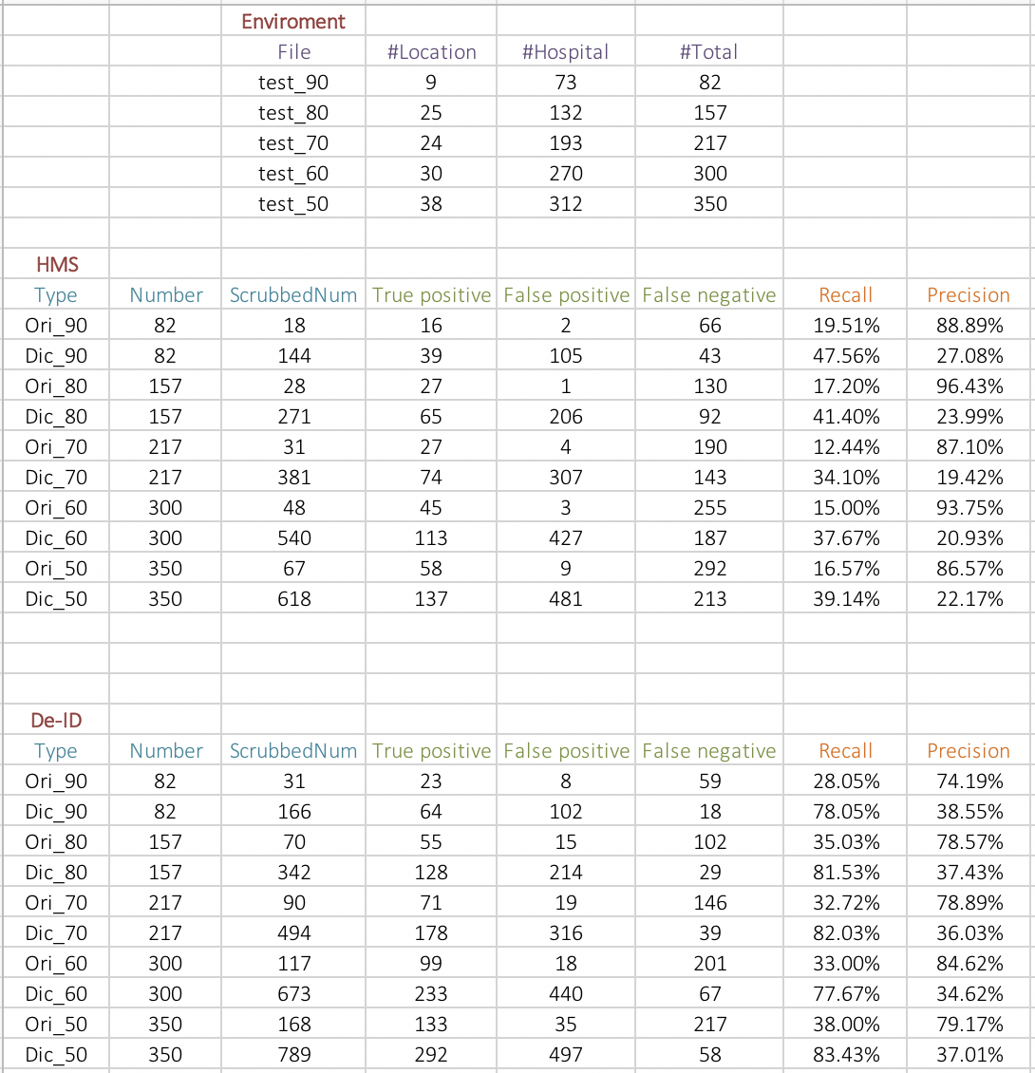

*Note: Position = Location + Hospital*

4. Analysis Data for section 3.1.2.2:

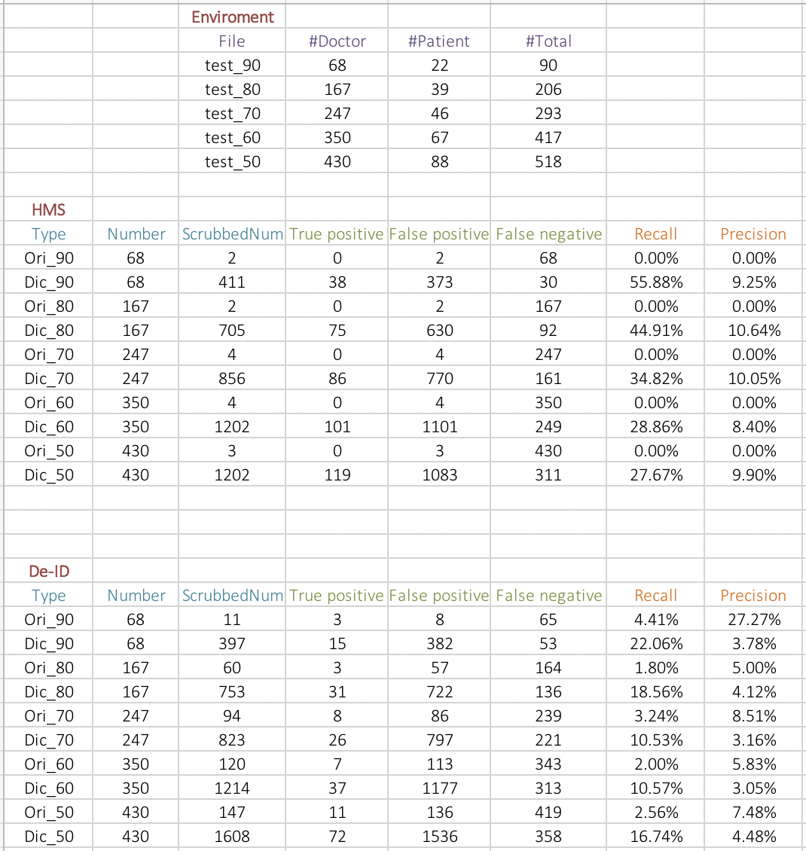

*Note: People = Doctor + Patient*